

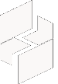

MICROSOFT ARCHITECTURE BEST PRACTICE FOR AI BUSINESS PROCESS
USECASE: MODERN ANALYTICS USING AZURE DATABRICKS

Document Title | Microsoft Cloud Center of Excellence Overview
Presales/Technical Head | Tushar Mehrotra/Rohit Pandey
CCoE Lead | Ravishankar N
Creation Date | 2nd January 2026
Version | Description | Modified by | Date | Approved by | Date
1 | Draft architecture baseline for review | Sharmila Devi K | 29/12/2025 | Ravi Shankar | 29/12/2025
2 | Updated draft with architecture refinements and review comments | Sharmila Devi K | 02/01/2026 | Ravi Shankar | 02/01/2026
Contents

1. Executive Summary 3
2. Scope and Applicability 3
3. Business Scenario Overview 3
4. Reference Architecture Overview 4
4.1 Architecture Description 4
5. Logical Architecture Components 5
5.1 Ingestion Layer 5
5.2 Storage Layer 5
5.3 Processing and Analytics Layer 5
5.4 Serving and Consumption Layer 6
6. Architectural Best Practices 6
6.1 Azure Well-Architected Framework Alignment 6
6.2 Governance & Data Management 6
6.3 Security and Compliance 6
7. Cloud Center of Excellence Enablement Model 7
8. Reusability and Scalability 7
9. Conclusion 7

Modern Analytics Architecture using Azure Databricks

Executive Summary
This document defines the standardized reference architecture and architectural best practices maintained by the Cloud Center of Excellence (CoE) to enable the design and delivery of modern analytics platforms using Azure Databricks.
The reference architecture is derived from the Microsoft Azure Architecture Center guidance for modern analytics architectures, where Azure Databricks acts as the central data engineering and analytics platform, integrated with Azure Data Lake Storage, Microsoft Fabric, and Power BI. [learn.microsoft.com]
This document serves as audit-ready evidence demonstrating the organization’s Cloud Center of Excellence capability, as required under Frontier Distributor checklist Section 3.1.1.

Scope and Applicability
This reference architecture applies to:
- CSP distributors and reseller ecosystems
- Data engineering, analytics, and AI workloads
- Batch, streaming, and real-time analytics scenarios
- SMB, Mid-Market, and Enterprise customers
- Regional and global CSP authorizations
The architecture supports consistent implementation across regions, enabling a globally aligned Cloud Center of Excellence.

Business Scenario Overview
Organizations generate data from multiple sources, including transactional systems, SaaS platforms, IoT devices, and applications. Traditional analytics platforms struggle to scale, govern, and integrate advanced analytics and AI workloads.
Azure Databricks enables:
- Unified analytics and AI on an open lakehouse architecture
- Scalable processing of batch and streaming data
- Secure collaboration across data engineering, analytics, and data science teams
- Delivery of trusted, curated datasets for business intelligence
This modern analytics architecture supports end-to-end data lifecycle management and analytics-driven decision-making.

Reference Architecture Overview

4.1 Architecture Description
The solution follows a modern lakehouse-based analytics architecture, where:
- Data is ingested from multiple operational systems
- Azure Databricks processes and refines the data
- Azure Data Lake Storage stores data in open formats
- Curated data is consumed by downstream analytics and reporting tools
Azure Databricks acts as the central analytics hub in the architecture.
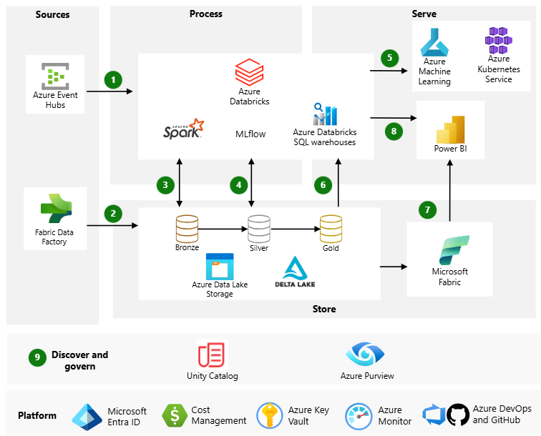

Logical Architecture Components

5.1 Ingestion Layer
- Azure Event Hubs for streaming ingestion
- Azure Data Factory / Fabric Data Factory for batch ingestion
- Native connectors and pipelines within Azure Databricks
These ingestion mechanisms support high-volume, diverse data sources.

5.2 Storage Layer
Azure Data Lake Storage Gen2
- Central, scalable data lake
- Stores structured, semi-structured, and unstructured data
- Uses open formats such as Parquet and Delta
Delta Lake
- Provides ACID transactions
- Supports schema enforcement and evolution
- Enables reliable data pipelines

5.3 Processing and Analytics Layer
Azure Databricks
- Core data engineering and analytics platform
- Supports Apache Spark-based processing
- Enables machine learning and SQL analytics
Medallion Architecture
- Bronze: raw ingested data
- Silver: cleansed and refined data
- Gold: aggregated, business-ready data
The medallion architecture is a Microsoft-recommended best practice for modern analytics platforms.

5.4 Serving and Consumption Layer
- Microsoft Fabric for SaaS-based analytics and AI
- Power BI for interactive dashboards and reports
- Direct lake and SQL-based consumption models
This layer enables business users to consume trusted insights efficiently.

Architectural Best Practices

6.1 Azure Well-Architected Framework Alignment
Pillar | Implementation Approach
Reliability | Managed Databricks workspaces, Delta Lake
Security | Azure RBAC, private networking, encryption
Performance | Autoscaling Spark clusters
Cost Optimization | Job clusters, workload isolation
Operational Excellence | CI/CD and monitoring integration
Azure Databricks is designed to support well-architected analytics workloads on Azure.

6.2 Governance & Data Management
- Centralized data governance using Unity Catalog
- Role-based access to data assets
- Data lineage and metadata management
- Environment separation (dev/test/prod)
Governance capabilities ensure consistent and auditable analytics operations across the organization.

6.3 Security and Compliance
- Identity management via Microsoft Entra ID
- Secure access to data lake and Databricks workspaces
- Network isolation and private endpoints
- Continuous monitoring and logging
Security controls align with enterprise and regulated workload requirements.

Cloud Center of Excellence Enablement Model
The Cloud Center of Excellence:
- Defines standardized modern analytics architectures
- Maintains reusable architectural patterns and templates
- Provides guidance and enablement for resellers
- Ensures alignment with Microsoft-recommended architectures
- Governs solution quality and delivery consistency across regions
This operating model meets the Cloud Center of Excellence requirements defined in the Frontier Distributor checklist.

Reusability and Scalability
This reference architecture:
- Scales from SMB analytics platforms to enterprise lakehouses
- Supports real-time and batch workloads
- Enables AI and advanced analytics workloads
- Applies consistently across industries and regions

Conclusion
This Cloud Center of Excellence reference architecture provides a Microsoft-aligned, audit-ready, and repeatable implementation model for modern analytics platforms using Azure Databricks. It enables distributors to support reseller and customer analytics workloads while maintaining governance, scalability, and architectural excellence across the partner ecosystem.

